**EX. NO: 2 DATE: 08/09/2020**

**MakeFile**

**Screenshots:**

**Xming Server.**

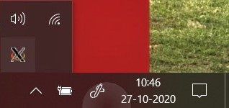

**Ubuntu commands:**



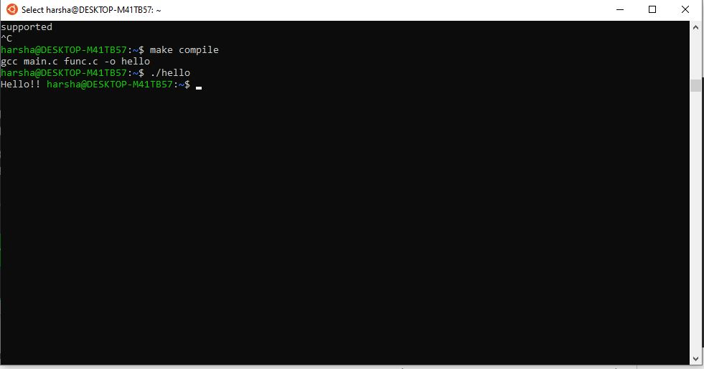

**Makefile :**

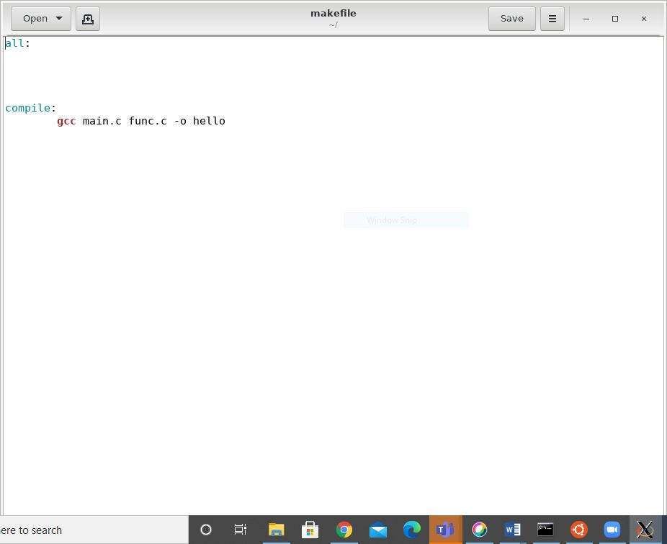

**C-FILES:**

**Main.c**

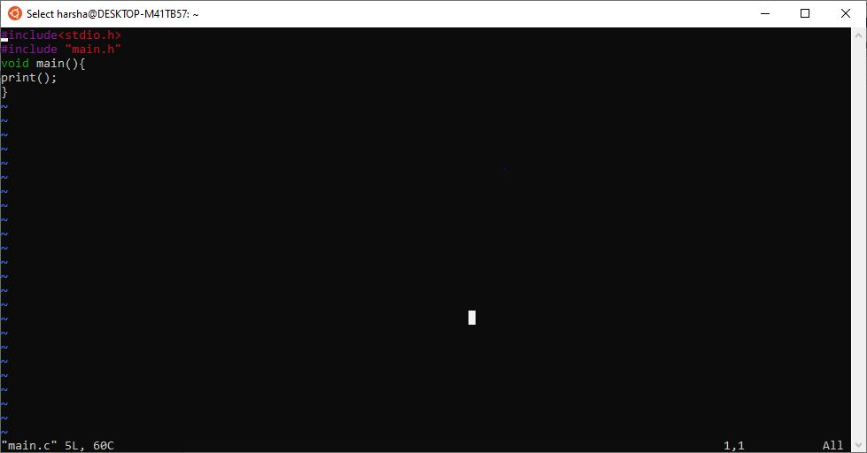

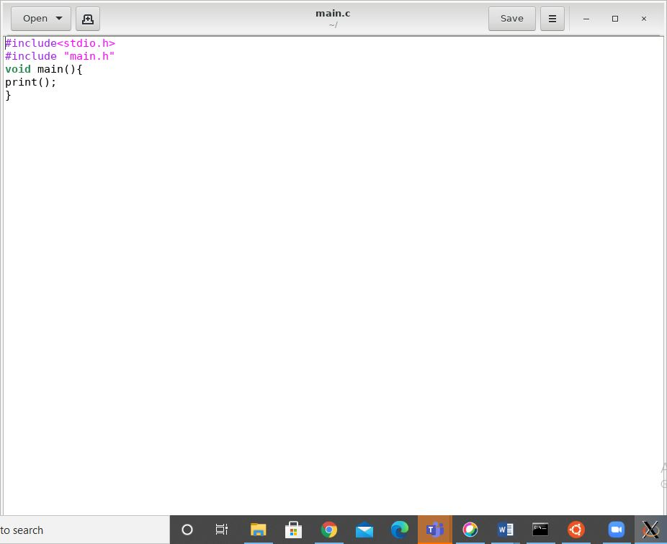

**func.c**

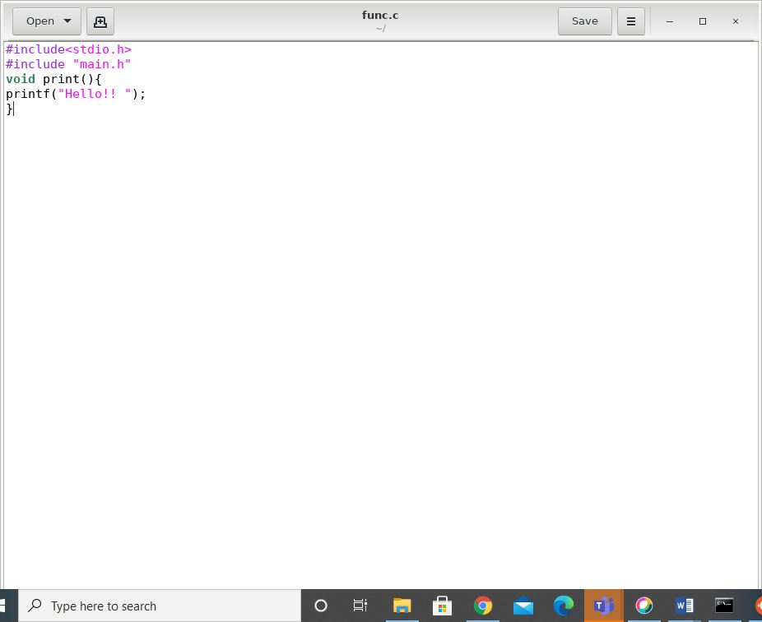

**Header file:**

**main.h**

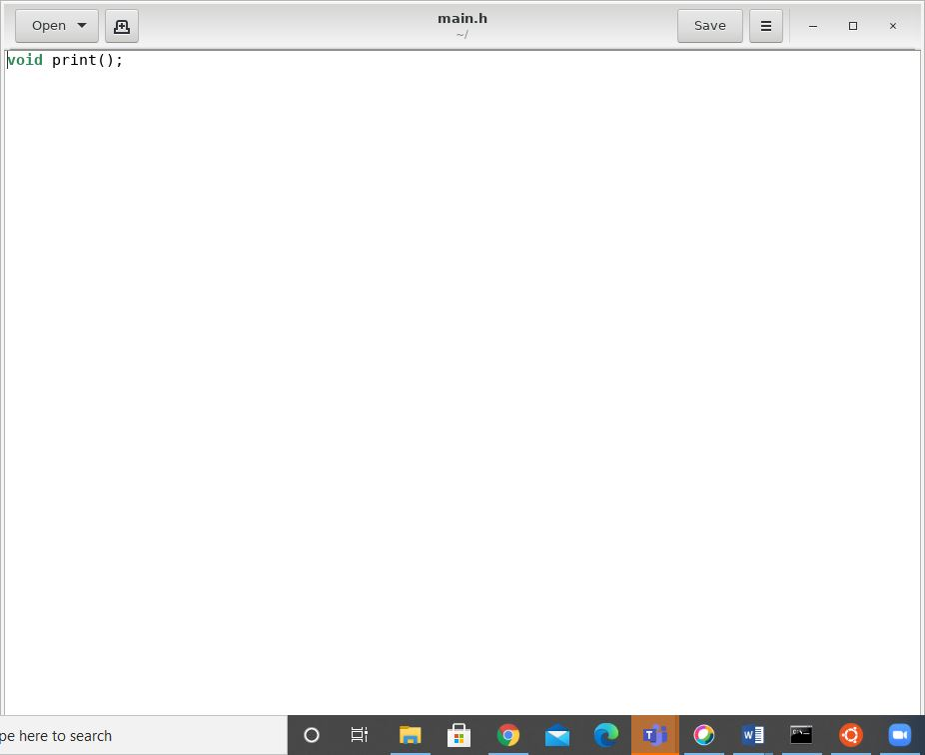

**Result:**

Hence, A C Program Has Been Splitted And Has Been Executed Successfully Using MakeFile Command.